COAL LAB TASKS 8
Task 1:
include Irvine32.inc

.data
msg1 byte "Enter numbers: ", 0
msg2 byte "Smallest even number: ", 0
msg3 byte "No even number found.", 0
num dword 2

.code
main proc

mov edx, OFFSET msg1
call WriteString
call CrLf

mov ecx, 10
L1:
call ReadDec
push eax
loop L1

mov ecx, 10
mov ebx, 0FFFFFFFFh

L2:
pop eax
test eax, 1
jnz not_even

cmp ebx, 0FFFFFFFFh
jne check_smallest
mov ebx, eax
jmp next_num

check_smallest:
cmp eax, ebx
jge next_num
mov ebx, eax
next_num:

not_even:
loop L2

cmp ebx, 0FFFFFFFFh
je no_even
mov edx, OFFSET msg2
call WriteString
mov eax, ebx
call WriteDec
jmp done

no_even:
mov edx, OFFSET msg3
call WriteString

done:
exit
main endp
end main

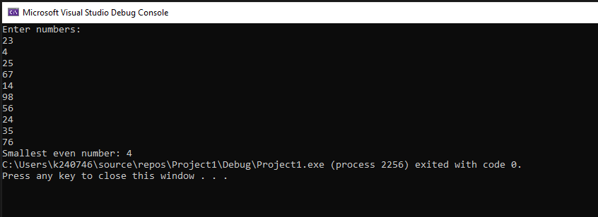
Task 2:
include Irvine32.inc

.data
salaries dword 5 dup(?)
sum dword ?
avg dword ?
msg1 byte "Enter salary: ",0
msg2 byte "Salaries:",0
msg3 byte "Sum: ",0
msg4 byte "Average: ",0

.code
main proc
call inputSalaries
exit
main endp

inputSalaries proc
mov ecx,5
mov esi,OFFSET salaries
L1:
mov edx,OFFSET msg1
call WriteString
call ReadDec
mov [esi],eax
add esi,4
loop L1
call computeSumAvg
ret
inputSalaries endp

computeSumAvg proc
mov ecx,5
mov esi,OFFSET salaries
mov eax,0
L2:
add eax,[esi]
add esi,4
loop L2
mov sum,eax
mov edx,0
mov ebx,5
div ebx
mov avg,eax
call displayResults
ret
computeSumAvg endp

displayResults proc
mov edx,OFFSET msg2
call WriteString
call CrLf
mov ecx,5
mov esi,OFFSET salaries
L3:
mov eax,[esi]
call WriteDec
call CrLf
add esi,4
loop L3
mov edx,OFFSET msg3
call WriteString
mov eax,sum
call WriteDec
call CrLf
mov edx,OFFSET msg4
call WriteString
mov eax,avg
call WriteDec
call CrLf
ret
displayResults endp

end main

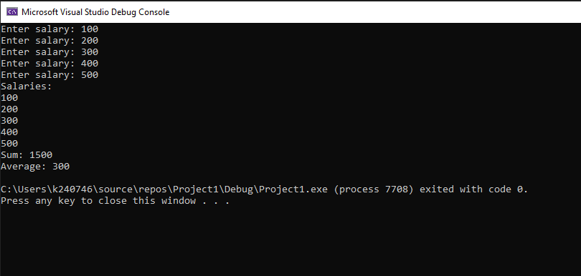
Task 3:
include Irvine32.inc

.data
msg1 byte "Enter temperature in Kelvin: ",0
msg2 byte "Kelvin: ",0
msg3 byte "Celsius: ",0
msg4 byte "Fahrenheit: ",0
msg5 byte "Stored Flags Value: ",0
msg6 byte "Popped Flags Value: ",0

kelvin dword ?
celsius dword ?
fahrenheit dword ?
flagsValue dword ?

.code
main proc
mov edx, OFFSET msg1
call WriteString
call ReadDec
mov kelvin, eax

sub eax, 273
mov celsius, eax

pushfd
pop flagsValue
push flagsValue

mov eax, celsius
mov ebx, 9
mul ebx
mov ebx, 5
div ebx
add eax, 32
mov fahrenheit, eax

mov edx, OFFSET msg2
call WriteString
mov eax, kelvin
call WriteDec
call CrLf

mov edx, OFFSET msg3
call WriteString
mov eax, celsius
call WriteDec
call CrLf

mov edx, OFFSET msg4
call WriteString
mov eax, fahrenheit
call WriteDec
call CrLf

mov edx, OFFSET msg5
call WriteString
mov eax, flagsValue
call WriteHex
call CrLf

pop eax
mov edx, OFFSET msg6
call WriteString
call WriteHex
call CrLf

exit
main endp
end main

